Production Environment and the Endpoint

When we discussed the *production environment*, the ***endpoint*** was defined as the **interface** to the model. This **interface** (***endpoint***) facilitates an ease of communication between the *model* and the *application*. Specifically, this **interface** (***endpoint***)

* Allows the *application* to send ***user data*** to the *model* and
* Receives ***predictions*** back from the *model* based upon that ***user data***.

### **Model, Application, and Endpoint**

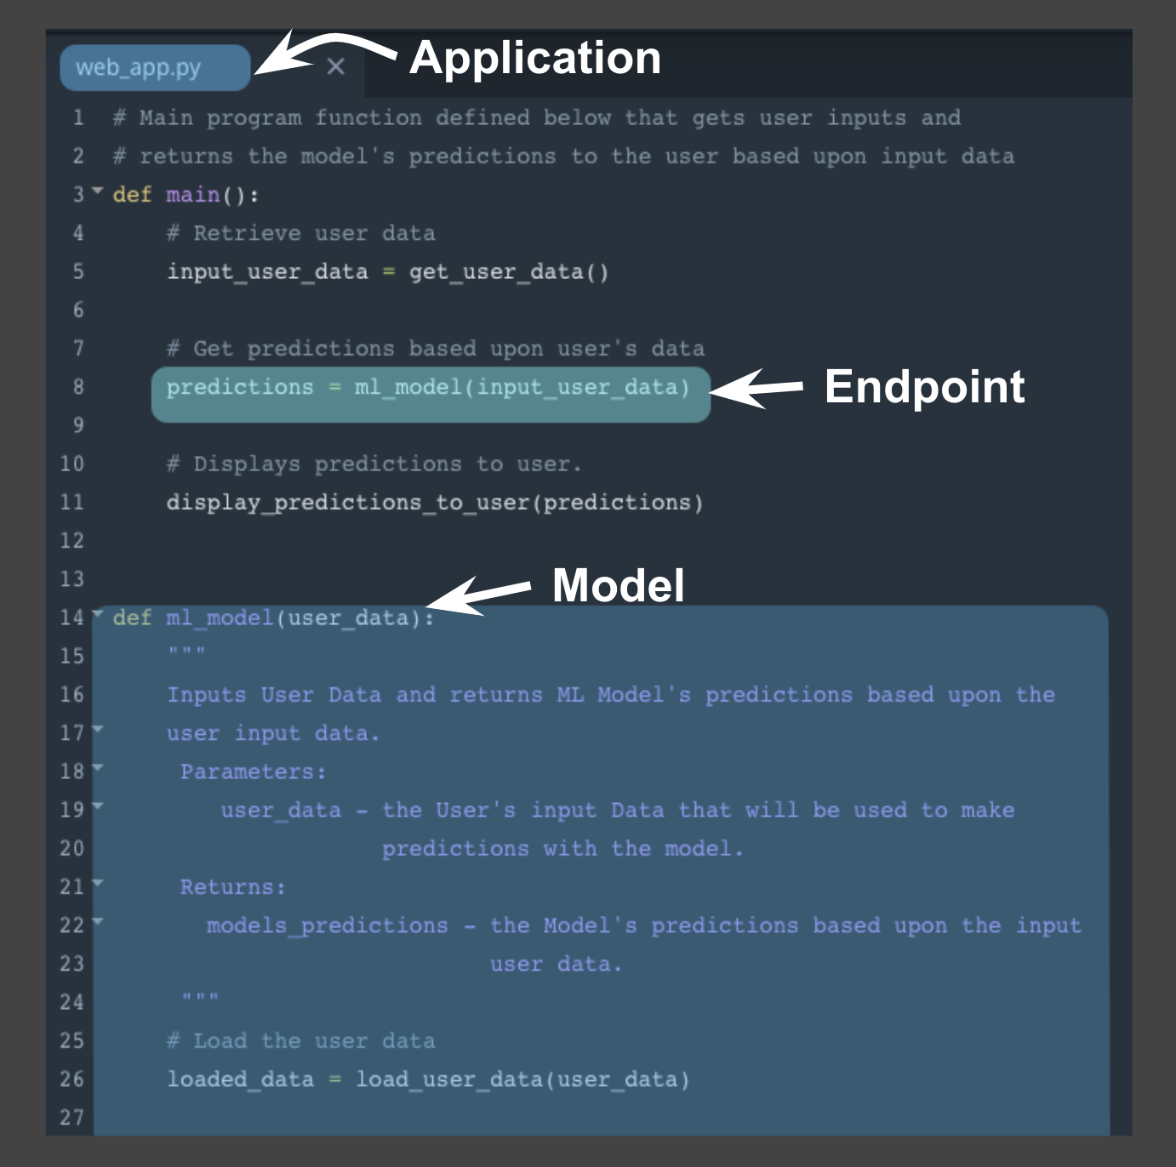

One way to think of the ***endpoint*** that acts as this *interface*, is to think of a *Python program* where:

* the **endpoint** itself is like a ***function call***
* the ***function*** itself would be the **model** and
* the ***Python program*** is the **application**.

The image **above** depicts the association between a ***Python program*** and the **endpoint**, **model**, and **application**.

* the **endpoint**: *line* ***8*** ***function call*** to **ml_model**
* the **model**: beginning on *line* ***14*** ***function definition*** for **ml_model**
* the **application**: ***Python program*** **web_app.py**

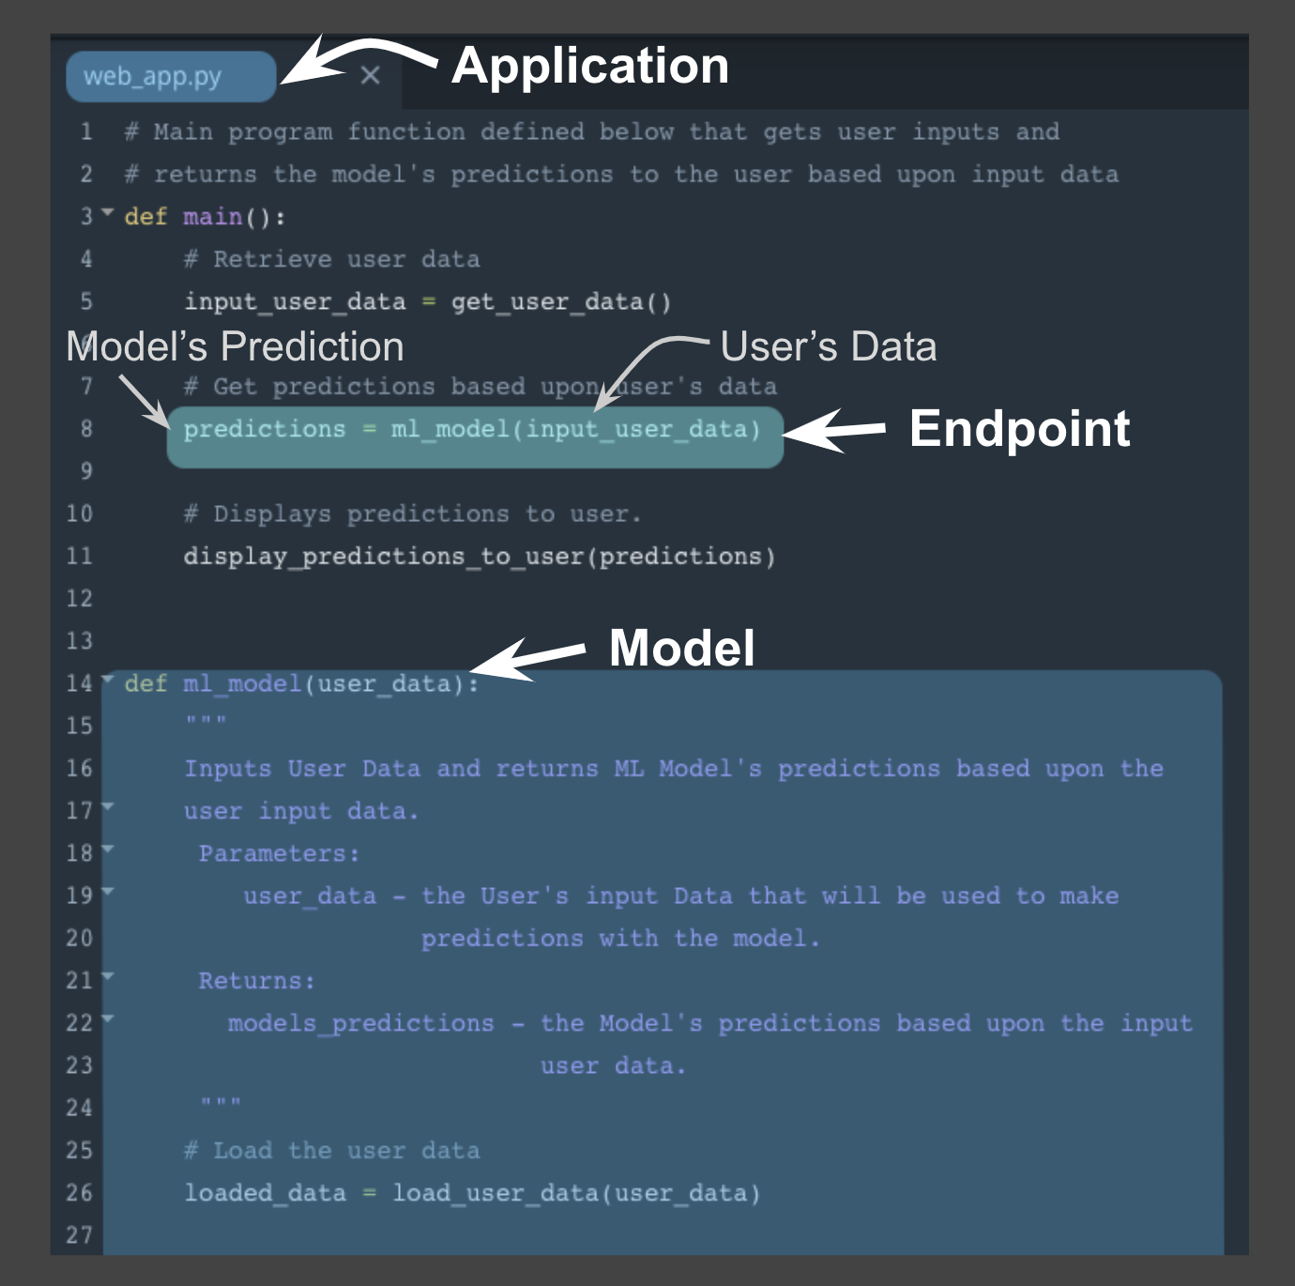

Using this example **above** notice the following:

* *Similar* to a ***function call*** the **endpoint** accepts *user data* as the ***input*** and ***returns*** the *model’s prediction* based upon this ***input*** through the **endpoint**.
* In the example, the *user data* is the ***input argument*** and the *prediction* is the ***returned value*** from the ***function call***.
* The **application**, here the ***python program***, displays the *model’s prediction* to the *application user*.

This example highlights how the **endpoint** itself is just the ***interface*** between the **model** and the **application**; where this ***interface*** enables users to get *predictions* from the ***deployed*** *model* based on their *user data*.

Next we'll focus on *how* the **endpoint** (***interface***) facilitates communication between **application** and **model**.

### **Endpoint and REST API**

Communication between the **application** and the **model** is done through the **endpoint** (***interface***), where the **endpoint** is an **Application Programming Interface** (**API**).

* An *easy* way to think of an **API**, is as a *set of rules* that *enable* programs, here the **application** and the **model**, to *communicate* with each other.
* In this case, our **API** uses a **RE**presentational **S**tate **T**ransfer, **REST**, architecture that provides a framework for the *set of rules* and *constraints* that must be adhered to for *communication* between programs.
* This **REST API** is one that uses *HTTP requests* and *responses* to enable communication between the **application** and the **model** through the **endpoint** (***interface***).
* Noting that ***both*** the **HTTP request** and **HTTP response** are *communications* sent between the **application** and **model**.

The **HTTP request** that’s sent from your **application** to your **model** is composed of *four* parts:

* **Endpoint**
  + This **endpoint** will be in the form of a URL, Uniform Resource Locator, which is commonly known as a web address.
* HTTP Method
  + Below you will find four of the **HTTP methods**, but for purposes of ***deployment*** our **application** will use the ***POST method*** *only*.
* HTTP Headers
  + The **headers** will contain additional information, like the format of the data within the message, that’s passed to the *receiving* program.
* Message (Data or Body)
  + The final part is the **message** (data or body); for ***deployment*** will contain the *user’s data* which is input into the **model**.

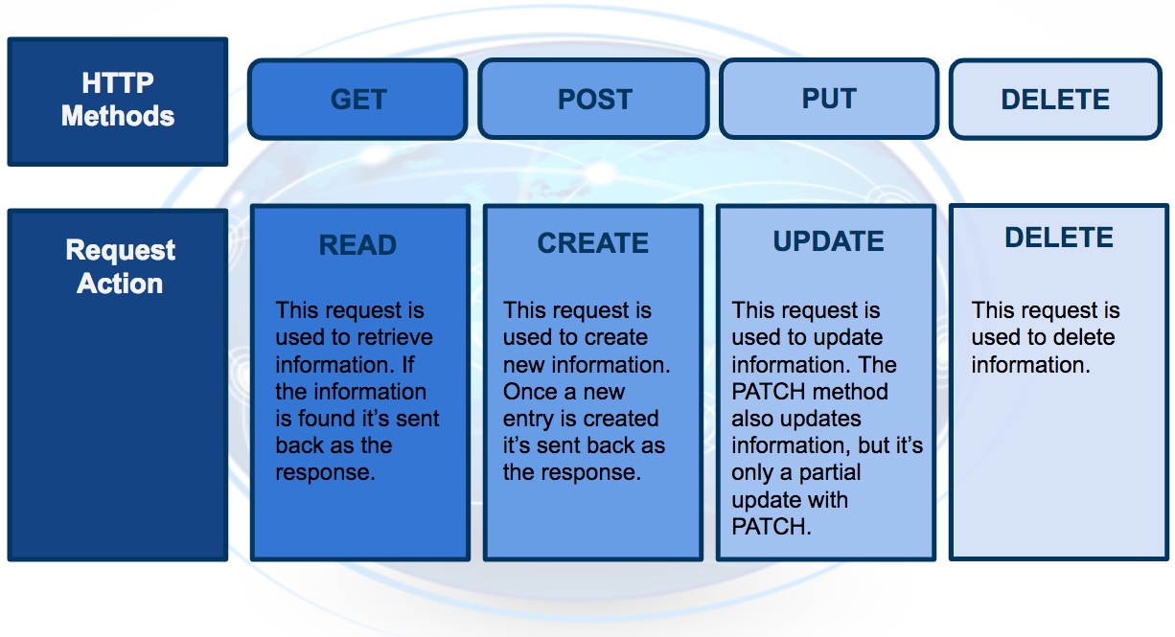

The **HTTP response** sent from your model to your application is composed of *three* parts:

* HTTP Status Code
  + If the model successfully received and processed the *user’s data* that was sent in the **message**, the status code should start with a ***2***, like *200*.
* HTTP Headers
  + The **headers** will contain additional information, like the format of the data within the **message**, that’s passed to the receiving program.
* Message (Data or Body)
  + What’s returned as the *data* within the **message** is the *prediction* that’s provided by the **model**.

This *prediction* is then presented to the *application user* through the **application**. The **endpoint** is the ***interface*** that *enables communication* between the **application** and the **model** using a **REST API**.

As we learn more about **REST*ful* API**, realize that it's the **application’s** responsibility:

* To format the *user’s data* in a way that can be easily put into the **HTTP request** ***message*** and ***used*** by the **model**.
* To translate the *predictions* from the **HTTP response** ***message*** in a way that’s easy for the *application user’s* to understand.

Notice the following regarding the *information* included in the ***HTTP messages*** sent between **application** and **model**:

* Often *user's data* will need to be in a *CSV* or *JSON* format with a specific *ordering* of the data that's dependent upon the **model** used.
* Often *predictions* will be returned in *CSV* or *JSON* format with a specific *ordering* of the returned *predictions* dependent upon the **model** used.